**Ticket Management System**



**Submitted to: Submitted by:**

TBI Department                    Abhishek Singh Negi

GEU, D.Dun University Roll No.:2118110

CSE-D-VI-Sem

**Table of Contents**

|  |  |  |
| --- | --- | --- |
| **Chapter No.** | **Description** |  |
| Chapter 1 | Introduction |  |
| Chapter 2 | Literature Survey |  |
| Chapter 3 | Methodology |  |
| Chapter 4 | Result and Discussion |  |
| Chapter 5 | Conclusion  References |  |

**INTRODUCTION**

The Ticket Management System is a Python-based application that leverages the Tkinter framework for its graphical user interface (GUI) and SQLite for backend database connectivity. This system is designed to facilitate various Ticket operations, such as ticket bookings, passenger data management, and train schedule inquiries. Users interact with the system through an intuitive GUI, where they can input, update, delete & retrieve information. The application integrates seamlessly with an SQLite database, ensuring efficient and persistent storage of data. This project showcases the effective use of Python and its libraries in creating a functional, user-friendly desktop application for managing Ticket-related tasks, highlighting the practicality and versatility of Python in solving real-world problems.

**LITERATURE SURVEY**

* **Academic Journals and Conferences:** Papers discussing the use of Python for developing desktop applications, focusing on its efficiency, ease of use, and the applicability of Tkinter in GUI development.
* **Case Studies:** Real-world examples where Python and Tkinter have been used in system development, especially in transportation or logistics.
* **Technical Papers:** Research on the use of SQLite in small to medium-scale applications, its performance, reliability, and suitability for desktop applications like a Ticket Management System.
* **Industry Reports:** Analysis of trends in database management systems, particularly the adoption and efficacy of SQLite in various sectors.
* **Emerging Technologies:** Exploration of new technologies and methodologies that could enhance Ticket Management Systems.

A literature survey in this area aims to build a comprehensive understanding of the technological, practical, and theoretical aspects of developing a Ticket Management System using Python, Tkinter, and SQLite. This survey can help identify best practices, common challenges, and innovative approaches that can be applied to create an effective and efficient system.

**Methodology**

**1. Setting Up the Environment:**

* Install Python and set up an environment.
* Ensure Tkinter is installed (tkinter comes pre-installed with Python).
* Install SQLite (sqlite3 module is included in Python's standard library).

**2. Database Setup:**

* Create a SQLite database file.
* Define a table structure for storing passenger information. For example, a table named Passengers with columns for name, age, sex, class, berth, phone number, food preferences, source station, destination station, and travel date.

**3. Building the GUI with Tkinter:**

* Develop the main application window using Tkinter.
* Add input fields for name, age, sex, class, berth, phone number, food preference, source station, destination station, and date.
* Include buttons for operations: Add, Update, Delete, and Show Records.

**4. Implementing Database Interactions:**

* Write functions to interact with the SQLite database.
* Add Record: Insert new passenger details into the database.
* Update Record: Modify existing passenger details.
* Delete Record: Remove passenger details from the database.
* Show Records: Retrieve and display passenger details from the database.

**5. Integrating GUI with Database Functions:**

* Connect the GUI elements with database functions.
* When the Add button is clicked, gather data from input fields and call the Add Record function.
* For Update and Delete, implement a mechanism to select which record to modify or delete (e.g., through a list or ID input).
* The Show Records button should display a list or table of all passenger records.

**6. Adding Additional Functionalities:**

* Implement input validation to ensure data integrity.
* Add error handling for database operations and user inputs.

**7. Testing the Application:**

* Perform thorough testing for each functionality: add, update, delete, and display.
* Test the application for different scenarios and edge cases.

**8. Deployment and Usage:**

* Finalize the application for deployment.
* Provide instructions for using the system, including how to add, update, delete, and view records.

**Framework & Database Used**

* **TKinter**

Tkinter is the standard Graphical User Interface (GUI) library for Python, providing a fast and easy way to create GUI applications. It is a thin object-oriented layer on top of Tcl/Tk, which is one of the oldest and most popular GUI toolkits. Tkinter comes pre-installed with Python, ensuring a smooth out-of-the-box experience for developers. It allows the creation of windows, buttons, text fields, and other standard GUI elements through simple and intuitive Python commands, making it highly accessible for beginners. Despite its simplicity, Tkinter is quite powerful and versatile, suitable for a wide range of applications from small scripts to complex, multi-windowed applications. Its lightweight nature makes it an ideal choice for projects where a simple yet effective interface is needed without the overhead of more comprehensive libraries like PyQt or Kivy. Furthermore, Tkinter applications are cross-platform and can run on Windows, macOS, and Linux, providing a uniform look and feel across different operating systems. The community around Tkinter is robust, with ample tutorials, guides, and third-party extensions available, making it a well-supported choice for GUI development in Python.

* **SQLite**

SQLite is a widely used database engine renowned for its simplicity, reliability, and lightweight nature, making it a popular choice for a variety of applications, including desktop, mobile, and embedded systems. In the context of Python, SQLite is particularly significant due to its direct integration with the language through the `sqlite3` module, which comes as part of Python's standard library. This integration allows Python developers to utilize a full-fledged relational database system without requiring a separate server, unlike more traditional databases such as MySQL or PostgreSQL. SQLite operates on a single file, which makes it exceptionally easy to set up and manage, as it doesn't require any complex configuration or management. It supports standard SQL syntax and features, including transactions, indices, and complex queries, enabling developers to perform robust data operations with minimal overhead. This makes SQLite an ideal choice for small to medium-sized applications, rapid prototyping, and for situations where simplicity and minimalism are key requirements. Despite its simplicity, SQLite is highly reliable and capable, boasting impressive performance and standards compliance, which has led to its widespread adoption in a multitude of applications across various domains.

**RESULT AND DISCUSSION**

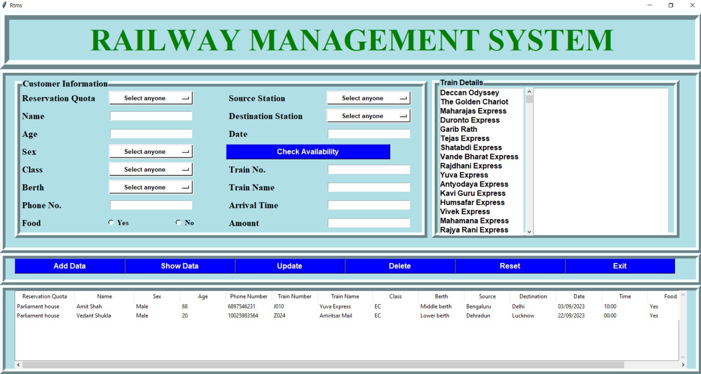

*User will enter the data and check for availability of train . Then with help of different buttons, the data get stored in database and further it can be update and delete. The ticket will also be generated of the particular user.*

**CONCLUSION**

**The Ticket Management System project, leveraging Python, Tkinter, and SQLite, presents an efficient and user-friendly solution for handling Ticket reservations and customer data management. By using Python, a powerful and versatile programming language, the system ensures a robust backend. Tkinter, Python's standard GUI toolkit, offers a simple yet effective interface for users to input their details such as name, age, sex, class, berth preference, phone number, food preferences, and journey details including source and destination stations, and travel date. The incorporation of SQLite for database connectivity allows for a lightweight, yet reliable storage mechanism for managing the large amount of data typically associated with Ticket systems. This system not only simplifies the process of Ticket reservation for users but also streamlines the data handling and management aspect for the authorities. With its straightforward design and implementation, this project is a testament to the power of combining Python, Tkinter, and SQLite to solve real-world problems in the domain of public transportation management.**

**REFERENCES**

* **Python Documentation:** For the fundamentals of Python, the official Python documentation is indispensable. It provides comprehensive details on syntax, modules, and best practices.
* **Tkinter Tutorials:** Since Tkinter is used for the GUI, tutorials like TkDocs offer detailed guidance on widgets, layout management, and event handling. Another valuable resource is GeeksforGeeks Tkinter Tutorial, which provides examples and explanations for various Tkinter components.
* **SQLite in Python:** Understanding how to work with SQLite in Python is crucial. The SQLite Python Tutorial by Tutorialspoint is a good starting point. It covers basic to advanced concepts of working with SQLite databases in Python.
* **Ticket System Specifics:** To get insights into how real-world Ticket systems work, resources like research papers or articles on Ticket reservation systems can be useful. Websites like ResearchGate may have relevant publications.
* **GitHub Repositories:** GitHub is a treasure trove of projects and code samples. Searching for Ticket management systems or similar projects on GitHub can provide you with real-world code examples and implementation ideas.
* **Online Programming Communities:** Platforms like Stack Overflow, Reddit’s r/learnpython, and Python Forum can be useful for asking specific questions and learning from the challenges and solutions of others who have undertaken similar projects.
* **Video Tutorials:** Websites like YouTube have numerous video tutorials covering Python, Tkinter, and SQLite. Channels dedicated to programming and software development, such as Corey Schafer or Sentdex, offer step-by-step guides that can be extremely helpful.